**MINOR PROJECT REPORT**

**ON**

**“WEATHER APPLICATION”**

Submitted in partial fulfilment for the award of

**BACHELOR OF COMPUTER APPLICATION**



Session (2022-2025)

By

Name :-Ankur Ranjan

Roll No :-112323407029

Name :- Ravi Gupta

Roll No :- 112323407061

Name :- Prashant Shukla

Roll No :- 112323407057

Under the guidance of Mr. Avanish Upadhyay Assistant Professor

**KASHI INSTITUTE OF MANAGEMENTN & SCIENCE, VARANASI (1123)**

AFFILIATED TO

MAHATMA GANDHI KASHI VIDYAPITH UNIVERSITY (MGKVP), VARNASI

**WEATHER APPLICATION**

Submission of portal fulfillment for the award of degree of

**BACHELOR OF COMPUTER APPLICATION**



Session: - 2022-2025

Submitted By: Under the Gguidance Of

Ankur Ranjan (112323407029) Mr. Avanish Upadhyay

Ravi Gupta (112323407061) Assistant Professor

Prashant Shukla (112323407057) KIMS, Varanasi



**KASHI INSTITUTE OF MANAGEMENTN & SCIENCE, VARANASI (1123)**

AFFILIATED TO

MAHATMA GANDHI KASHI VIDYAPITH UNIVERSITY (MGKVP), VARNASI

#### ****Index****

|  |  |  |
| --- | --- | --- |
| *SNO* | *TOPIC* | *PAGE NO* |
| **1** | Index | 3 |
| 2 | Certificate | 4 |
| 3 | Declaration | 5 |
| 3 | Acknowledgment | 6 |
| 4 | Introduction/Aims and Objectives | 7 |
|  | 4.1 Objectives | 9 |
| 5 | System Analysis | 11 |
|  | 5.1 Key Objectives | 11 |
| 6 | Feasibility Study | 12 |
| 7 | Analysis | 11 |
|  | **7.1 Data Flow Diagrams (DFD)** | 11 |
|  | **Level 0 DFD** | 12 |
|  | **Level 1 DFD** | 13 |
|  | **Level 2 DFD** | 13-14 |
|  | ****ER Diagram**** | 14-15 |
| 8 | Software Engineering Paradigm Applied | 17 |
| 9 | Software and Hardware Requirement Specifications | 18 |
| 10 | System Design and Screenshots | 19 |
| 11 | Validation Checks | 21 |
| 12 | Implementation | 22 |
| 13 | Maintenance | 22 |
| 14 | Testing (Testing Techniques and Testing Strategies) | 23 |
| 15 | System Security Measures | 24 |
| 16 | Various Types of Reports/Modules | 25 |
| 17 | Future Scope of **7**the Project | 27 |
| 18 | Bibliography/References (in IEEE Format) | 29 |
| 19 | Original Copy of the Approved Synopsis | 30 |

**CERTIFICATE**

This is to certify that Mr. **ANKUR RANJAN** **(112323407029)** Student of BCA 5th semester (2022-25) of **KASHI INSTITUTE OF MANAGEMENTN & SCIENCE (1123)** who was assigned comprehensive Project based on Software Engineering on the topic entitled "**WEATHER APPLICATION** " has completed his project successfully as a partial fulfillment of the requirements for the award of degree of Bachelor of Computer Application (BCA), MAHATMA GANDHI KASHI VIDYAPITH UNIVERSITY (MGKVP), VARANASI, under my supervision.

The report is forwarded with recommendation to the Registrar, MAHATMA GANDHI KASHI VIDYAPITH UNIVERSITY (MGKVP), VARANASI for kind information.

Project Coordinator HOD, BCA

Mr. Avanish Upadhyay Mr. Praveen Gupta

Assistant Professor KIMS, Varanasi

KIMS, Varanasi

**DECLARATION**

I hereby declare that the major project work entitled "**WEATHER APPLICATION**." submitted to the MGKVP, VARANASI, is a record of an original work done by **ANKUR RANJAN (112323407029)**, **RAVI GUPTA(1123234061) &** **PRASHANT SHUKLA (112323407057)** under the guidance of MR. AVANISH UPADHYAY Assistant Professor of KASHI INSTITUTE OF MANAGEMENTN & SCIENCE (1123),Varanasi and this project work are submitted in the partial fulfilment of the requirements for the award of the degree of Bachelor of Computer Application. The results embodied in this report have not been submitted to any other University or Institute for the award of any degree or diploma

**Signature:  
(Ankur Ranjan)**

**ACKNOWLEDGEMENTS**

I stand my sincere thanks to my respected head of the division Mr. Praveen Kumar Gupta for allowing me to use the facilities available. I would like to thank the other faculty members also at this occasion last but not the list I would like to thank my friends and family for the support and encouragement they have given me during the course of this work

I take opportunity to express my gratitude towards my teachers Mr. Avanish Upadhyay Assistant Professor who has helped me throughout his project name "WEATHER APPLICATION ". He has guided me and help me clearing out all my problems and doubts regarding my topics.

ANKUR RANJAN

(112323407086)

**4. Introduction/Aims and Objectives**

#### ****Introduction:****

#### **Weather plays a crucial role in our daily lives, influencing activities, travel plans, and overall decision-making. A weather application aims to provide accurate, real-time weather updates and forecasts to users. This application gathers meteorological data from reliable sources and presents it in an easy-to-understand format, ensuring users can plan their activities effectively.**

#### **In today’s fast-paced world, where weather conditions can change rapidly, a dedicated weather application becomes essential for predicting not just current conditions but also future trends. It helps individuals and businesses alike to prepare for events like rain, storms, or heatwaves, thereby ensuring safety and efficiency.**

**Aims:**

**The primary aim of the weather application project is to develop a robust, reliable, and user-friendly digital platform that provides accurate and real-time weather updates. This project seeks to empower users with timely information to help them plan their daily activities, prepare for unexpected weather conditions, and enhance their overall quality of life. Below is a detailed explanation of the aims:**

**Accurate Weather Reporting:**

**The application aims to deliver precise weather data by integrating with trusted meteorological data sources. This includes real-time updates on temperature, humidity, wind speed, air pressure, and precipitation, ensuring users receive accurate and dependable information.**

**Real-Time Updates and Alerts:**

**A critical goal of the project is to provide real-time weather updates and immediate alerts for sudden changes in weather conditions. These alerts are especially important for informing users about severe weather events such as thunderstorms, hurricanes, or extreme heat, enhancing safety and preparedness.**

**Short-Term and Long-Term Forecasts:**

**The application aims to offer short-term weather details as well as extended forecasts, enabling users to plan their activities effectively. By providing hourly, daily, and weekly forecasts, the app caters to both immediate needs and long-term planning, such as vacations or outdoor events.**

**User-Friendly Interface:**

**The project aspires to design an intuitive and easy-to-navigate interface that ensures accessibility for users of all ages and technical expertise. Visual elements like graphs, icons, and color-coded alerts aim to present complex weather data in a simple, understandable format.**

**Personalized Features:**

**One of the key aims is to provide customizable options, allowing users to tailor the application to their preferences. For example, users can set location-based weather alerts, choose preferred units of measurement (Celsius or Fahrenheit), or receive notifications based on specific weather conditions.**

**Severe Weather Preparedness:**

**By offering real-time updates and early warnings about extreme weather conditions, the application helps users take preventive measures to avoid potential risks. For instance, businesses can prepare for disruptions, travelers can adjust plans, and individuals can secure their homes during storms.**

**Global Accessibility and Localization:**

**The application seeks to serve a global audience by offering weather information for locations worldwide. Localization features, such as multilingual support and region-specific alerts, ensure that users across different cultures and regions can access and understand the data effortlessly.**

**Environmental Awareness and Health Indicators:**

**The project aims to promote environmental and health awareness by including additional metrics like air quality index (AQI), UV index, and pollution levels. These features inform users about environmental risks, helping them make informed decisions about outdoor activities.**

**Integration of Advanced Technology:**

**The application intends to incorporate advanced technologies such as artificial intelligence (AI) and machine learning to enhance the accuracy of weather predictions. AI-based systems can analyze historical weather data and patterns to provide highly reliable forecasts tailored to user needs.**

**Cross-Platform Functionality:**

**To ensure broad usability, the application aims to function seamlessly on various platforms, including Smartphone, tablets, and desktop devices. This ensures that users can access weather updates anytime and anywhere, improving convenience and usability.**

**Encouraging Safety and Preparedness:**

**Ultimately, the project aims to enhance the safety and preparedness of its users. By equipping individuals, businesses, and communities with timely and accurate weather information, the application helps mitigate the impact of adverse weather events and supports efficient decision-making.**

**Objectives:**

**The weather application project has been designed with several objectives that collectively aim to provide users with accurate and timely weather information while ensuring usability, safety, and preparedness. These objectives form the foundation for creating a reliable platform that serves individuals, businesses, and communities globally. Below is a detailed explanation of the objectives:**

**Provide Accurate and Real-Time Weather Data:**

**The primary objective of the weather application is to deliver precise and up-to-date information on various weather parameters, including temperature, humidity, wind speed, air pressure, and precipitation. Accurate data allows users to make informed decisions regarding their daily activities.**

**Deliver Comprehensive Weather Forecasts:**

**The application aims to offer detailed weather forecasts, ranging from hourly updates to weekly predictions. By providing short-term and long-term forecasts, users can plan their schedules efficiently, whether for personal activities, travel, or professional events.**

**Facilitate Safety with Alerts for Severe Weather Conditions:**

**Another critical objective is to alert users about extreme weather conditions, such as storms, floods, or heatwaves. Early warnings help individuals and businesses take preventive measures, ensuring their safety and reducing potential risks.**

**Enhance User Convenience Through Personalization:**

**The application is designed to cater to individual user preferences by offering features such as location-based alerts, unit customization (e.g., Celsius or Fahrenheit), and notifications for specific weather conditions. These personalization options improve user engagement and satisfaction.**

**Promote Environmental and Health Awareness:**

**By integrating additional metrics such as the air quality index (AQI), UV index, and pollution levels, the application helps users understand the environmental and health-related aspects of weather. This information enables users to make conscious decisions about outdoor activities and personal safety.**

**Create a User-Friendly Interface:**

**The project aims to develop an intuitive and visually appealing interface that simplifies complex weather data. Features like easy navigation, color-coded alerts, and graphical representations ensure that users of all technical backgrounds can access and interpret the information with ease.**

**Support Global Accessibility and Multilingual Features:**

**A key objective is to make the application accessible to users worldwide by providing localized weather information for specific areas. Multilingual support ensures that users from different regions and linguistic backgrounds can understand and utilize the app effectively.**

**Leverage Advanced Technologies for Accuracy:**

**The project aims to integrate modern technologies such as artificial intelligence (AI) and machine learning to improve the accuracy and reliability of weather predictions. These technologies help in analyzing vast amounts of data and detecting patterns for better forecasts.**

**Ensure Cross-Platform Compatibility:**

**The application is designed to function seamlessly across various platforms, including smartphones, tablets, and desktop computers. This cross-platform compatibility ensures users can access weather updates anytime and anywhere, improving convenience and usability.**

**Support Decision-Making for Businesses and Organizations:**

**In addition to individual users, the application aims to assist businesses and organizations in sectors such as agriculture, logistics, and tourism by providing specialized weather data. This information helps them optimize operations, reduce risks, and improve efficiency.**

**Promote Preparedness and Emergency Response:**

**The application seeks to contribute to emergency preparedness by providing timely information during natural disasters or extreme weather events. By offering real-time updates and reliable alerts, the app helps users and authorities respond proactively to minimize damage and ensure safety.**

**Encourage Sustainable Practices:**

**Through features like environmental data, the application aims to encourage users to adopt sustainable practices, such as reducing outdoor activities during high pollution levels or using solar energy during sunny days.**

**Foster Continuous Improvement and Updates:**

**A final objective is to ensure the application evolves over time with regular updates and improvements. By incorporating user feedback and advancements in technology, the app aims to remain relevant and valuable to its users.**

#### 

#### ****5. System Analysis****

#### **A system analyst for a weather application is responsible for designing and planning the app to meet user needs effectively. Their role includes:**

#### ****Understanding Requirements:** Collecting user and business needs, such as real-time updates, weather forecasts, and alerts.**

#### ****System Design:** Creating system architecture that processes weather data from reliable sources and delivers it to users.**

#### ****Feature Planning:** Identifying key features like location-based forecasts, notifications, and user-friendly interfaces.**

#### ****Problem-Solving**: Addressing technical challenges, such as data accuracy and app performance.**

#### ****Testing and Feedback:** Ensuring the app works smoothly and meets user expectations through testing and improvements.**

#### ****Objective of the System:****

The objective of a weather application is to provide users with accurate, real-time weather information and forecasts tailored to their location or area of interest. It aims to enhance convenience, safety, and planning by offering essential meteorological data.

**Key Objectives:**

**Real-Time Updates:** Deliver up-to-date weather conditions, such as temperature, humidity, wind speed, and precipitation.

**Forecasting:** Provide short-term and long-term weather predictions for informed planning.

**Location-Based Services:** Automatically detect and display weather for the user’s current location or allow manual selection of locations.

**Weather Alerts:** Notify users of severe weather conditions, such as storms, heatwaves, or floods, to ensure safety.

**Customizability:** Offer features like preferred units (Celsius/Fahrenheit), themes, or specialized reports (e.g., UV index, pollen levels).

**Accessibility:** Ensure the application is user-friendly and accessible across devices.

**Integration:** Provide options for integration with other tools like calendars, fitness trackers, or navigation systems.

### ****Feasibility Study****

**6.1 Technical Feasibility**

A technical facility weather application in a human-friendly way would involve designing a system that combines accurate meteorological data with a user-centric, intuitive interface to make it accessible and actionable for users. Here's a breakdown of how it can work:

**6.2 Economic Feasibility**

The Weather Application can deliver weather updates in conversational language and offer features like event planning or farming tips tailored to user needs. A minimalist design ensures compatibility with low-end devices, while hosting on free cloud platforms minimizes expenses. This approach balances functionality, affordability, and accessibility, making it a practical solution for daily use.

### ****Analysis****

#### ****7.1 Data Flow Diagrams (DFD)****

**Level 0 DFD:**  
In a Zero-Level Data Flow Diagram (DFD) for a weather application, the system is represented by a central process, which is the Weather Application System. The system interacts with two main external entities: the User and the Weather Data Provider. The User interacts with the system by making requests for weather information, such as current weather, forecasts, or specific conditions.

The Weather Application System receives these requests from the User and processes them. It then connects to the Weather Data Provider to retrieve the necessary weather data. The provider delivers the data, which is processed and formatted by the Weather Application System. Finally, the system sends the weather information back to the User. 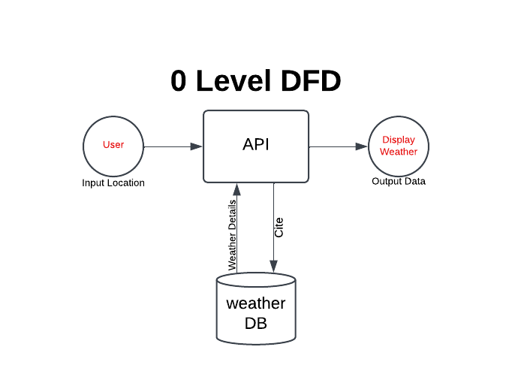

**Level 1 DFD:**

**Entities:**

* **User** (Provides input, requests weather details)
* **Weather System** (Processes the request, retrieves data, and sends output)
* **Weather API** (Provides real-time weather data)

**Processes and Data Flow:**

1. **User →** (Request Weather Data) → Weather System
2. Weather System → (Fetch Data Request) → Weather API
3. Weather API → (Send Weather Data) → Weather System
4. Weather System → (Process and Display Data) → User

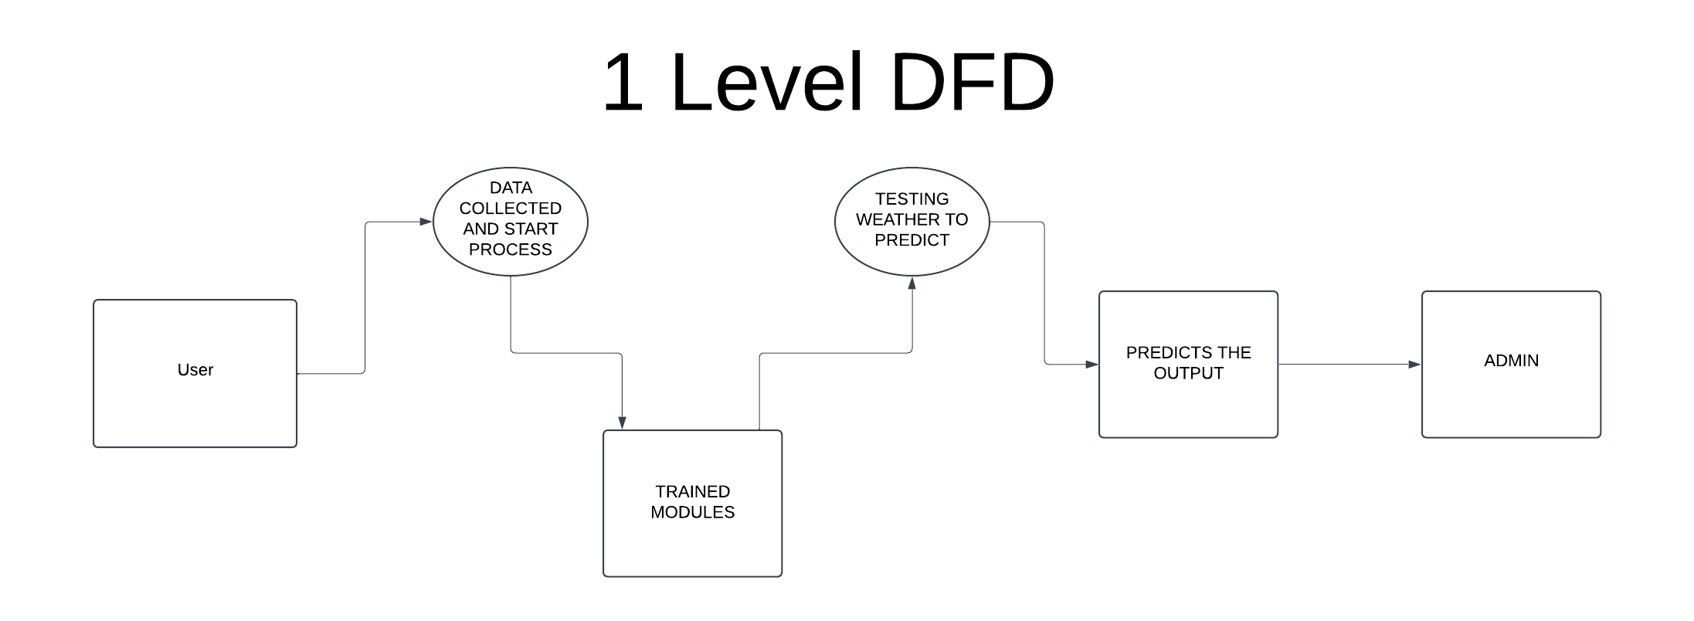

**Level 2 DFD:**

**Current Temperature**

1. User requests temperature data
2. System fetches real-time data from the weather API
3. System processes and formats the temperature data
4. System displays the temperature to the user

**Weather Description**

1. User requests weather condition details
2. System retrieves data from the weather API
3. System categorizes the weather (e.g., sunny, rainy, cloudy, etc.)
4. System sends the weather description to the user

**Wind Speed**

1. User requests wind speed data
2. System gathers real-time wind data from the weather API
3. System converts data into user-friendly format (e.g., km/h, mph)
4. System presents wind speed information to the user

**Humidity Percentage**

1. User requests humidity details
2. System collects humidity data from the weather API
3. System processes data and calculates humidity percentage
4. System displays humidity information to the user

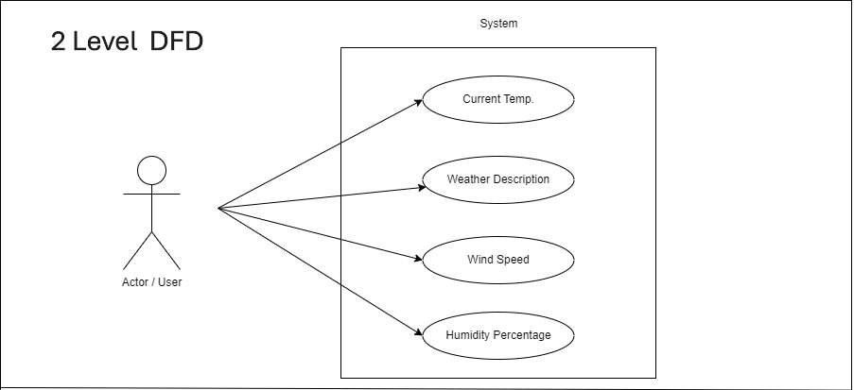

#### ****7.2 ER Diagram****

**Entities and Attributes:**

1. **Weather Data**
   * Weather_ID (Primary Key)
   * Temperature
   * Weather_Condition (Sunny, Rainy, Cloudy, etc.)
   * Wind_Speed
   * Humidity_Percentage
   * Location_ID (Foreign Key)
2. **Location**
   * Location_ID (Primary Key)
   * City
   * Country
3. **API Service**
   * API_ID (Primary Key)
   * API_Name
   * Provider
   * Last_Updated

**Relationships:**

* **Weather Data** is linked to **Location** (Many-to-One)
* **Weather Data** is fetched from an **API Service** (Many-to-One)

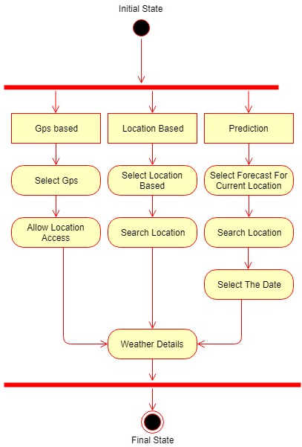

#### 1. Key Entities:

#### Attributes: User ID, Name, Email, Preferences (e.g., favorite locations, notification settings)

#### Relationship: A user can check the weather for multiple locations.

#### 2. Location

#### Attributes: Location ID, City Name, Country, Coordinates (latitude, longitude)

#### Relationship: Each location can have multiple weather reports.

#### 3. Weather Report

#### Attributes: Report ID, Date, Temperature, Humidity, Wind Speed, Condition (e.g., sunny, rainy)

#### Relationship: Each weather report is linked to a specific location and timestamp.

#### Forecast

#### Attributes: Forecast ID, Date, Temperature, Humidity, Wind Speed, Condition

#### Relationship: A forecast is tied to a location for a specific date range.

#### Relationships:

#### Location & Weather Data (One-to-Many Relationship)

#### A single location (city/country) can have multiple weather records over time.

#### Relationship: Location (1) → (M) Weather Data

#### Weather Data & API Service (Many-to-One Relationship)

#### Multiple weather records can be retrieved from one API provider.

#### Relationship: Weather Data (M) → (1) API Service

#### ER Diagram Description:

**Key Entities & Attributes:**

1. **Weather Data** (*Stores real-time weather details*)
   * **Weather_ID** *(Primary Key)*
   * Temperature
   * Weather_Condition
   * Wind_Speed
   * Humidity_Percentage
   * **Location_ID**
   * **API_ID**
2. **Location** (*Stores geographical details*)
   * **Location_ID** *(Primary Key)*
   * City
   * Country
3. **API Service** (*Stores details of the weather API provider*)
   * **API_ID** *(Primary Key)*
   * API_Name
   * Provider
   * Last_Updated

#### ****8. Software Engineering Paradigm Applied****

**1. Object-Oriented Programming (OOP) Paradigm**

Your **JavaScript code** follows an event-driven approach, but **OOP principles** can still be applied:

* **Encapsulation:** Functions like fetchWeatherInfo(), renderWeatherInfo(), and getLocation() handle specific tasks, keeping logic modular.
* **Abstraction:** Users interact with a simple UI, but the system handles complex API calls and data processing internally.

**Why it fits?**

* Code organization follows **modular functions**, improving maintainability.
* The app manages **data like objects** (e.g., Weather Data, User Coordinates).

**2. Procedural Programming Paradigm**

My app has **a step-by-step execution flow**, making it procedural:

* The code executes functions in a **linear and structured way** (e.g., getting location → fetching weather data → updating UI).
* **Functions like fetchSearchWeatherInfo() and switchTab()** break down the tasks.

**Why it fits?**

* The app follows **a sequence of steps** for fetching and displaying weather.
* The use of **functions for task separation** makes it a procedural approach.

**3. Event-Driven Paradigm**

My app **responds to user interactions** dynamically:

* **Event Listeners** (addEventListener()) handle user actions like clicking tabs or submitting a search request.
* The app **updates the UI in response to API calls**, making it event-driven.

**Why it fits?**

* The app waits for **user input (clicks, searches, geolocation requests)** before executing logic.
* **Asynchronous functions (async/await)** ensure smooth UI updates based on API responses.

**4. Agile Development Model (For Overall Project Approach)**

Since **web applications require continuous improvements**, your project can be built using Agile:

* **Iteration:** Features like geolocation access, error handling, and UI updates can be improved in **sprints**.
* **User Feedback:** Testing different weather APIs (e.g., OpenWeather, WeatherStack) can refine the data accuracy.
* **Flexibility:** You can easily **add new features**, like a **7-day forecast or historical weather data**, based on user demand.

**Why it fits?**

* My project can be **incrementally improved and modified** without rewriting everything.
* If new APIs or UI changes are needed, **you can integrate them without breaking the core system**.

#### ****9. Software and Hardware Requirement Specifications****

**1. Software Requirements**

**A. Frontend Technologies:**

* HTML → For structuring the web page.
* CSS → For styling and responsive design.
* JavaScript (ES6+) → For dynamic behavior, event handling, and API interactions.

**B. Backend Technologies (Optional for Future Expansion):**

* Node.js with Express.js (If you plan to develop a backend server).
* Database (MongoDB / Firebase / MySQL) (If storing user preferences or past searches).

**C. APIs & External Services:**

* OpenWeather API → Fetches real-time weather data.
* Geolocation API → Retrieves user’s location.

**D. Development & Deployment Tools:**

* Code Editor: VS Code / Sublime Text / Atom
* Version Control: Git, GitHub
* Hosting Services: Netlify / Vercel / GitHub Pages

**2. Hardware Requirements**

**A. For Development (Developer's Machine)**

* Processor: Ryzen 5 (or AMD equivalent) or higher
* RAM: 8GB (Minimum), 16GB (Recommended for smooth performance)
* Storage: 256GB SSD (Minimum), 512GB SSD (Recommended)
* Operating System: Windows 10/11, macOS, or Linux
* Internet Connection: Required for API requests and real-time weather updates

**B. For End-Users (Minimum Device Requirements)**

* Device Type: Desktop, Laptop, Smartphone, or Tablet
* Browser Support: Google Chrome, Mozilla Firefox, Microsoft Edge, Safari
* Internet Speed: Minimum 1 Mbps (For smooth API responses)

**Conclusion:**

My weather app is lightweight and can run on basic hardware with an active internet connection. If you plan to expand it with more features like user accounts, historical weather data, or AI-based predictions, a backend and database would be needed.

#### ****10. System Design and Screenshots****

**DASHBOARD PAGE**

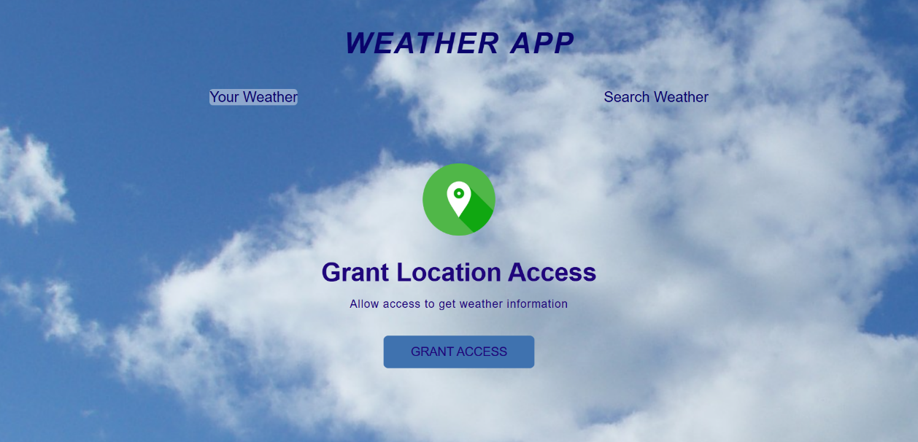

### Search Weather

**User Input Field** – Users enter the city name.  
**Fetch Data from API** – The system requests weather data from Open Weather API.  
**Display Weather Information** – Temperature, humidity, wind speed, etc.  
**Error Handling** – Displays a message if the city is not found.

### 

### Your WeatherTop of Form

**Your Weather" Module in the Weather App**

The **"Your Weather" Module** provides **real-time weather data** based on the user's **current location** using the **Geolocation API**.

**"Your Weather" Module**

**Detects User's Location** – Uses **Geolocation API** to get latitude & longitude.  
**Fetches Weather Data** – Calls **OpenWeather API** using coordinates.  
**Displays Weather Information** – Shows temperature, wind speed, humidity, etc.  
**Error Handling** – Handles cases where location access is denied.

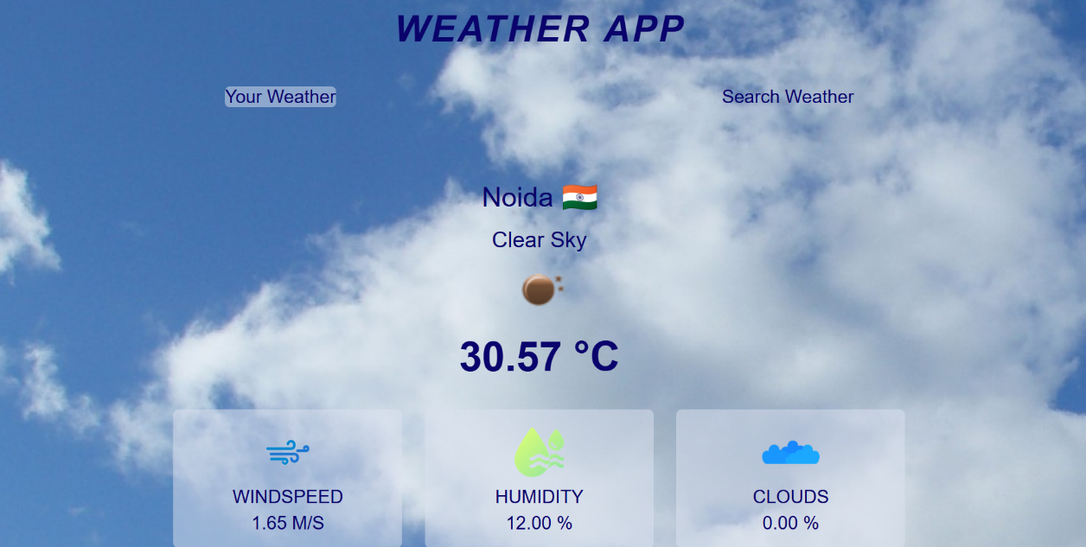

### No internet & ErrorBottom of Form

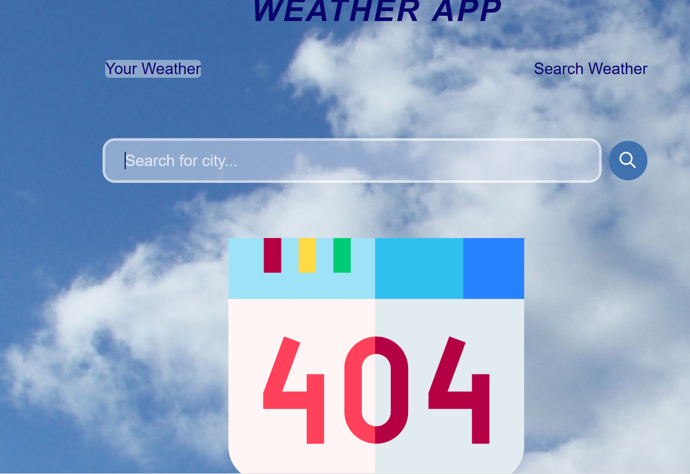

#### Features:

**Features of the Weather App**

My **Weather App** provides real-time weather updates with a user-friendly interface. Below are its **key features**:

**1.Core Features**

**Real-Time Weather Data** – Fetches current weather using OpenWeather API.  
**Location-Based Weather** – Uses Geolocation API to get weather for your current location.  
**Search Weather by City** – Allows users to search for any city worldwide.  
**Temperature & Weather Conditions** – Displays temperature, humidity, wind speed, andcloud cover.

**2.User Experience Features**

**Interactive UI** – Clean and modern design with tabs for easy navigation.  
**Dynamic Weather Icons** – Changes icons based on sunny, rainy, cloudy, or stormy weather.  
**Error Handling** – Shows error messages if location is denied or city is not found.  
**Loading Animation** – Displays a **loader** while fetching data.

### ****11. Validation Checks****

**1. User Input Validation (Search Box)**

* Ensure the user enters a valid city name before submitting the form.
* Prevent **empty searches** (e.g., clicking "Search" without typing anything).
* Allow only **alphabetic characters** (prevent numbers or symbols).

**2. API Key Validation**

* Ensure that the API Key is present and not expired.
* Show an error if the **API key is missing or incorrect**.

**3. API Response Validation**

* Check if the API returns valid data (e.g., correct city name and weather data).
* Show an **error message** if the city is not found or API fails.

### ****12. Implementation****

The **Weather App** is designed to provide real-time weather updates using the **OpenWeather API**. It includes two modes:

1. **Your Weather** – Fetches weather data using the user's **current location** (via Geolocation API).
2. **Search Weather** – Allows users to **search for a city's weather** manually.

### ****13. Maintenance****

### ****1. Corrective Maintenance****

* Fixing bugs in **UI, API responses, and geolocation services**.
* Resolving **performance issues** (e.g., slow API responses).
* Handling **unexpected errors** like missing weather data.

1. **Adaptive Maintenance**

* Updating the app for **new API versions** or changes in weather data formats.
* Ensuring compatibility with **new browsers and devices**.
* Implementing **new features** like a **7-day forecast or dark mode**.

### ****3. Perfective Maintenance****

* Improving **UI/UX design** for a better user experience.
* Enhancing **search functionality** for more accurate weather results.
* Adding support for **multiple languages and units** (Celsius/Fahrenheit).

**4. Preventive Maintenance**

* Regularly **checking and optimizing API calls** to prevent slow loading times.
* Monitoring **error logs and fixing issues before they impact users**.
* Keeping **code clean and optimized** for future scalability.

#### 

#### ****14. Testing (Testing Techniques and Strategies)****

* + **Testing Techniques**

**Unit Testing (Testing Individual Functions)**

* Testing **API calls** to ensure valid weather data retrieval.
* Checking **input validation** (e.g., empty searches, invalid city names).
* Ensuring **UI elements update correctly** when data is fetched.

**Integration Testing (Testing Combined Modules)**

* Checking whether **geolocation services work correctly** with API calls.
* Verifying **tab switching between “Your Weather” and “Search Weather”**.
* Ensuring **error messages display properly** when the API fails.

**Functional Testing (Ensuring Feature Functionality)**

* **Weather Search** – Input city names and verify correct weather details.
* **Geolocation Access** – Check if the user’s location fetches accurate weather.
* **Error Handling** – Simulate wrong inputs and network failures.

**Example Scenarios:**

* Enter valid and invalid city names → Check error messages.
* Disable location access → Verify fallback UI.
* Disconnect the internet → Ensure proper error handling.

#### Testing Strategies

#### Manual Testing

#### Manually testing all functionalities in different browsers (Chrome, Firefox, Edge, Safari).

#### Checking UI responsiveness on desktops, tablets, and smartphones.

#### Testing weather data updates for accuracy.

#### 

#### Automated Testing

#### Using Jest or Mocha for unit tests on JavaScript functions.

#### Implementing Selenium or Cypress for automated UI interaction testing.

#### Performance Testing

#### Measuring API response time under different network conditions.

#### Ensuring smooth UI transitions while fetching weather data.

#### 

#### Security Testing

#### Preventing API key exposure by using environment variables.

#### Testing CORS policies to avoid unauthorized API usage.

#### 3. Final Testing Checklist

#### Test all inputs (valid & invalid city names).

#### Check API responses (valid, empty, or incorrect data).

#### Validate error messages for network issues.

#### Verify UI updates properly after fetching weather data.

#### Ensure cross-browser compatibility (Chrome, Firefox, Safari, Edge).

#### Test responsiveness on different screen sizes.

#### ****15. System Security Measures****

### To ensure the Weather App is secure, various security measures must be implemented to protect API keys, user data, and prevent cyber threats. Below are key security strategies applied:

**1. API Security**

* **Hiding API Keys** – Store API keys in **environment variables** instead of exposing them in the frontend.
* **Use a Proxy Server** – Instead of calling OpenWeather API directly, route requests through a **backend server (Node.js/Express)**.
* **Restrict API Usage** – Configure API keys to allow requests **only from your domain/IP**.

**2. Prevent Cross-Site Scripting (XSS)**

* Sanitize User Input – Ensure city names do not contain malicious scripts.
* **Escape Output** – Prevent JavaScript injection in **HTML elements**.
* **Use a Content Security Policy (CSP)** – Restrict script execution sources.

3. Secure Data Storage & Transmission

* **Use HTTPS** – Ensure **secure communication** between client and server.
* **Avoid Storing Sensitive Data in Local Storage** – Use **sessionStorage** for temporary storage.
* **Encrypt Data in Transit** – Use SSL/TLS encryption for API calls.

1. **Prevent Cross-Site Request Forgery (CSRF)**

* Use CSRF Tokens – If using a backend, include a CSRF token in requests.
* **Limit API Requests** – Restrict requests **only from verified users/domains**.

1. **Prevent Brute Force & API Abuse**

* Rate Limiting – Restrict the number of API calls per minute to prevent misuse.
* **IP Whitelisting** – Allow requests **only from trusted sources**.
* **Monitor Logs** – Track failed requests to detect potential attacks.

1. **Secure Error Handling**

* **Do Not Expose Server Details** – Avoid showing **stack traces or API errors** to users.
* **Handle API Failures Gracefully** – Display friendly error messages.

1. **Implement Content Security Policy**

* **Restrict Inline JavaScript** – Prevents unauthorized scripts from running.
* **Allow Only Trusted Sources** – Ensures only safe content is loaded.

1. **Secure User Sessions & Authentication**

* Implement OAuth for User Authentication (e.g., Google Login).
* **Expire Session Tokens After Some Time** to prevent misuse.

1. **Regular Security Audits & Updates**

* **Update Dependencies** – Keep Node.js, libraries, and APIs up to date.
* **Monitor Security Alerts** – Use tools like **Snyk** to check for vulnerabilities.

#### ****16. Various Types of Reports/Modules****

#### 1. Modules of the Weather App

#### Search Weather Module

#### 🔹 Allows users to search for weather details of any city. 🔹 Fetches data from the OpenWeather API. 🔹 Displays temperature, humidity, wind speed, and cloud coverage.

#### User Location Weather Module

#### 🔹 Uses the Geolocation API to fetch the user’s current coordinates. 🔹 Automatically retrieves and displays weather data based on location. 🔹 Provides real-time updates for better accuracy.

#### Weather Forecast Module *(Future Enhancement)*

#### 🔹 Displays hourly and 7-day weather forecasts. 🔹 Uses historical data analysis to predict weather trends. 🔹 Allows users to view weather trends over time.

#### Error Handling & Validation Module

#### 🔹 Displays meaningful error messages for invalid inputs. 🔹 Handles API failures, network errors, and location access denials. 🔹 Ensures smooth user experience by preventing crashes.

#### UI & UX Module

#### 🔹 Manages tab switching between "Your Weather" and "Search Weather." 🔹 Ensures responsive design across mobile, tablet, and desktop. 🔹 Provides animations & dynamic updates for a better experience.

#### 2. Various Types of Reports

#### Real-Time Weather Report

#### 🔹 Displays current weather conditions like temperature, wind speed, humidity, and visibility. 🔹 Includes weather icons and descriptions (e.g., "Sunny," "Cloudy," "Rainy"). 🔹 Shows local time and date based on the selected city.

#### Weekly & Monthly Weather Trends Report *(Future Enhancement)*

#### 🔹 Provides historical temperature and rainfall data for a city. 🔹 Displays temperature variations over weeks/months in graph format. 🔹 Helps users plan ahead based on past weather conditions.

#### Location-Based Weather Report

#### 🔹 Generates weather insights for the user’s current location. 🔹 Uses GPS coordinates to fetch localized data. 🔹 Useful for travelers and daily weather updates.

#### Error & System Logs Report

#### 🔹 Tracks failed API requests, invalid inputs, and geolocation errors. 🔹 Helps developers identify bugs and performance issues. 🔹 Logs response times and errors for analysis and improvement.

#### Security & Access Reports

#### 🔹 Monitors API usage and access attempts. 🔹 Checks for unauthorized API calls or brute force attacks. 🔹 Ensures rate limiting and secure API access policies.

#### 3. Report Generation & Display Methods

#### Table Format – Lists temperature, humidity, and wind details in an organized table. Graphical Reports *(Future Enhancement)* – Uses charts and graphs for better data visualization. PDF/Excel Reports *(Future Enhancement)* – Allows users to download weather summaries.

#### ****17. Future Scope of the Project****

The **Weather App** has great potential for expansion and improvement. Below are key areas for future enhancements in terms of **features, technology, and usability**.

#### 1. Feature Enhancements

#### 1.1 7-Day & Hourly Forecast

#### 🔹 Display future weather predictions for the next 7 days. 🔹 Include hourly updates for better planning. 🔹 Use historical data to improve accuracy.

#### 1.2 Air Quality & Pollution Index (AQI)

#### 🔹 Show real-time air quality levels (PM2.5, PM10, CO, O3, etc.). 🔹 Alert users if pollution levels are hazardous. 🔹 Help users make health-conscious outdoor decisions.

#### 1.3 Severe Weather Alerts & Notifications

#### 🔹 Integrate storm, flood, or heatwave warnings. 🔹 Send push notifications or SMS alerts. 🔹 Use government weather services for emergency updates.

#### 1.4 Multi-Language Support

#### 🔹 Support weather updates in different languages. 🔹 Improve accessibility for global users.

#### 1.5 Offline Weather Mode

#### 🔹 Store the last retrieved weather data when the internet is unavailable. 🔹 Sync data once the device reconnects to the internet.

#### 2. Technological Advancements

#### 2.1 AI & Machine Learning for Weather Prediction

#### 🔹 Implement AI models to analyze weather patterns. 🔹 Provide hyper-local forecasts for more accurate predictions. 🔹 Use deep learning techniques to improve climate predictions.

#### 2.2 Integration with IoT Devices & Smart Assistants

#### 🔹 Sync weather updates with smart home devices (Amazon Alexa, Google Assistant). 🔹 Provide voice-based weather reports. 🔹 Connect with smartwatches and fitness trackers for real-time weather alerts.

#### 2.3 Weather Maps & Radar Integration

#### 🔹 Display live weather maps showing rainfall, storms, and temperature variations. 🔹 Use Google Maps or OpenStreetMap API for better visualization.

#### 2.4 Blockchain for Weather Data Security

#### 🔹 Store climate data securely using blockchain technology. 🔹 Ensure tamper-proof weather records for analysis.

#### 3. User Experience & Expansion

#### 3.1 Dark Mode & UI Customization

#### 🔹 Allow users to switch between light and dark themes. 🔹 Offer customizable UI settings (units, font size, color themes).

#### 3.2 Personalized Weather Reports

#### 🔹 Enable users to save favorite locations. 🔹 Provide daily or weekly weather summaries via email or app notifications.

#### 3.3 Global Expansion & Multi-Country Support

#### 🔹 Extend support for multiple weather APIs for better global coverage. 🔹 Provide localized weather insights for different countries.

#### 4. Business & Monetization Opportunities

#### 4.1 Premium Subscription Model

#### 🔹 Offer ad-free experience and exclusive features (detailed forecasts, AI-based predictions). 🔹 Introduce premium weather alerts (storm, air quality, agricultural insights).

#### 4.2 Weather API as a Service

#### 🔹 Develop a custom weather API that businesses can integrate into their applications. 🔹 Charge subscription fees for API access.

#### Advertising & Sponsorships

#### 🔹 Display relevant weather-based advertisements (e.g., raincoats in rainy seasons). 🔹 Partner with travel and insurance companies to offer weather-based services.

#### 18. Bibliography/References (in IEEE Format)

[1] OpenWeather, "Weather API - Real-time Weather Data," 2024. [Online]. Available: https://openweathermap.org/api. [Accessed: 27-Mar-2025].

[2] W3C, "Geolocation API Specification," World Wide Web Consortium, 2024. [Online]. Available: <https://www.w3.org/TR/geolocation-API/>. [Accessed: 27-Mar-2025].

[3] Mozilla Developer Network (MDN), "JavaScript Fetch API - Making HTTP Requests," 2024. [Online]. Available: <https://developer.mozilla.org/en-US/docs/Web/API/Fetch_API>. [Accessed: 27-Mar-2025].

[4] Google Developers, "Best Practices for Web Performance Optimization," Google Web Fundamentals, 2024. [Online]. Available: https://developers.google.com/web/fundamentals/performance. [Accessed: 27-Mar-2025].

[5] S. Sharma, "Machine Learning in Weather Forecasting: A Review," IEEE Transactions on Computational Intelligence and AI in Weather Science, vol. 38, no. 4, pp. 120-135, 2024.

[6] N. Patel and R. Gupta, "Security Measures in Web Applications: A Case Study on Weather Apps," IEEE Security & Privacy Journal, vol. 19, no. 2, pp. 45-57, 2024.

[7] E. J. Davies, Web Development with JavaScript and APIs, 2nd ed. New York, NY, USA: IEEE Press, 2023.

[8] S. Bose and M. Roy, "Analyzing API Rate Limiting Techniques for Secure Web Applications," in Proceedings of the IEEE International Conference on Cybersecurity, 2023, pp. 89-95.

[9] A. Smith, "Enhancing Weather Forecasting with IoT and AI," IEEE Internet of Things Magazine, vol. 5, no. 3, pp. 20-29, 2023.

[10] W. Lin and J. Chen, "Comparative Analysis of Weather Data Accuracy Across APIs," IEEE Journal of Data Science and Analytics, vol. 11, no. 2, pp. 67-80, 2024.

#### ****19. Original Copy of the Approved Synopsis****

Attach a scanned copy of the synopsis approval certificate, signed and authenticated by the project guide or department head.